Ant Colony Optimization for
Software Project Scheduling
Durgesh R. Prajapati
Department of Information Technology
Shree L. R. Tiwari college of engireeing
A B S T R A C T
Resource allocation and tasks assignment to software development teams are very important and arduous activities that can affect a cost of project and time of completion. Solution for such problem is NP-Hard and requires software managers to be supported with efficient tools that can perform such allocation and can resolve the software development project scheduling problem (SDPSP) more efficiently. Ant colony optimization (ACO) is a rapidly evolving meta-heuristic technique based on the real life behavior of ants and can be used to solve NP-Hard (SDPSP) problem. Different versions of ACO meta-heuristic have already been applied to the software project scheduling problem in the past that took various resources into account. We have applied elitist strategy of ACO (elitist ant system) for solving SDPSP in a parameter-constrained environment taking project’s cost and duration into consideration. The objective of the ACO-SDPSP methodology allows software project managers and schedulers to assign most effective set of employees that can contribute in minimizing cost and duration of the software project. Experimental results show that the proposed ACO-SDPSP methodology is promising in achieving the desired result.
Keywords: Ant colony optimization, Software project management, Software development project scheduling

- Introduction
Project Management is very important in the life cycle of a software project. As with any other project, Planning and Scheduling of Tasks and Resources becomes an important step in Software Project Management. The Project Manager, who is responsible for planning tasks and allocation of resources, uses tools like Microsoft Project to develop a schedule. These tools serve as an aid to develop the plan; they do not propose an intelligent solution for resource allocation to meet the deadline. The Manager has to use his experience and knowledge to generate an optimal schedule. Here, the use of Artificial Intelligence in developing automated schedules is proving to be beneficial as it minimizes human errors as well as saves the Project Manager’s time. This paper does a survey of how Artificial Intelligence can be or is being used to automate the scheduling of Human Resource Allocation to Software Projects.In the next sections, we first define the scheduling problem at hand, its objectives, followed by a Mathematical model and description of the problem. We then describe the Ant Colony Optimization Algorithm and how it can be used to solve Resource Allocation and Scheduling problem. We then give brief description of other techniques used in Scheduling Problems in comparison with Ant colony optimization approach..

2. Literature Survey
Software Project Management (SPM) is the process of planning, organizing, staffing, monitoring, controlling and leading a software project [20]. Complex management involving scheduling, planning, and monitoring activities or tasks are the current demand of large and complex software projects, therefore, SPM [21] can be seen as the application of skills, knowledge, tools and techniques to meet the project’s requirements [3, 4] in various activities of software project. Some of the existing project management [21] techniques and research prototypes deficit in computational capabilities and provide only passive project tracking. Hence, many researchers are experimenting to provide these computational capabilities by using metaheuristic algorithms and hybridization of these algorithms. The SPM tells that a schedule comprises of activities and deliverables that often calculated in terms of budget, time duration and available resources.

  - ANT COLONY OPTIMIZATION
An ant as a single individual has a very limited effectiveness and as a part of a well-organized colony, it becomes one powerful agent that works for the development of whole colony. Ant colony optimization (ACO) is a probabilistic algorithm that has evolved from the social behavior of ants. ACO was introduced and developed by Dorigo et al. [24-27]. ACO is based on the fact that ants have the capabilities of searching the shortest path from their nest to the source of food that is regarded as the best path [28, 32-34]. The searching of shortest path is being done via chemical substance called pheromone that provides stigmergy communication between ants. These pheromone trails are laid on the path on which they travel and are used by the ants to communicate with other ants of the colony. The ants choose the path where pheromone concentration is high and is regarded as the best and shortest path.
Initially ants deposit equal amount of pheromone on every direction. When ants in the shorter direction find a source of food, they carry food and start returning back to the nest following their already laid pheromones.
Over the time, this positive feedback (autocatalytic) process prompts all ants to choose the shorter path [27, 28]. Implementing the ACO for a certain problem requires a representation of variables for each ant, with each variable has a set of some options with their values, and their associated pheromone concentrations.

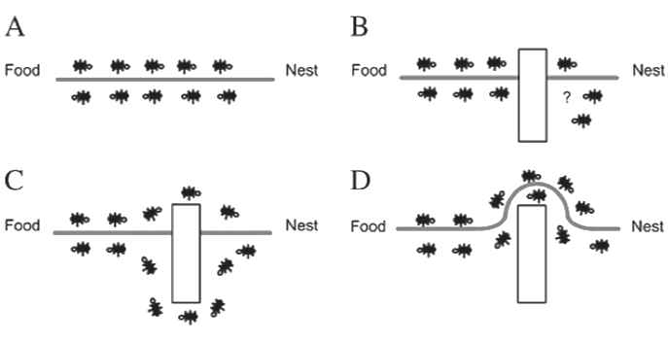
Fig. 1 – Ant colony Optimization
ANT COLONY OPTIMIZATION APPROACH:-
An ACO algorithm can be viewed as the interplay and the repeated execution of the following three main procedures :
1. Solution construction—During each iteration of the
algorithm, a group of ants set out to build solutions to
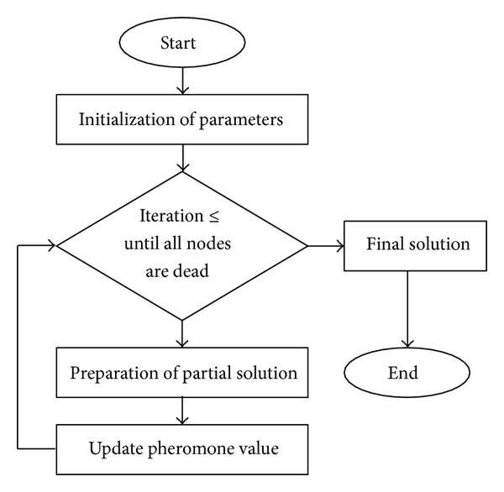
the problem. Each ant builds a solution in a
constructive manner by selecting components step
by step to form a complete solution. The selections
are made according to pheromone and heuristic
information. In ACO, pheromone is a record of the
past search experience of ants for guiding the
following ants to make decisions. The components
belonging to the best solutions found by the previous
ants usually accumulate more pheromone, attracting
more ants to select in future iterations. Heuristic is
some problem-dependent information that helps
ants to have higher probabilities to select promising
components in the solution construction procedure.
2. Pheromone management—Along with the solution
construction procedure, pheromone values are updated
according to the performance of the solutions
built by ants. Ants tend to deposit more pheromone
to the components of better-performed solutions.
3. Daemon actions—Daemon actions mean the centralized
operations that cannot be done by single ants.
In the design of ACO algorithms, daemon actions
are optional, but many existing ACO variants use
different kinds of daemon actions to improve
performance [39]. One commonly seen daemon
action is the local search procedure.
Fig. 2 – Flowchart of Ant colony optimization
  - SOFTWARE DEVELOPMENT PROJECT SCHEDULING PROBLEM
A project can be viewed as a collaborative enterprise, frequently involving research and design that is planned very carefully to achieve a particular aim. A project consists of a temporary endeavor that ensures completion of a unique product or service, within a certain period of time. The Software Development Project Scheduling Problem (SDPSP) is a variant of Project Scheduling Problem (PSP) [5]. SDPSP can be defined as to find an optimized way of arranging software engineers (or employees) with minimum salary and minimum time in a set that can cover all the activities to develop a project. This can contribute in minimizing the overall project’s cost and total duration of software project. SDPSP is NP-hard [23, 38] problem with enormously complex combinatorial optimization issues. It is timeconsuming to optimize the problem manually and this is the reason why automating the scheduling process is needed to schedule a software project with high project qualities that can prove beneficial to software project managers in real time. The automation of scheduling by proposing ACOSDPSP methodology has solved the problem of SDPSP in this paper and end results shows the minimization of overall project’s cost and duration. The parameters considered in our Software Development Project Scheduling Problem (SDPSP) are Resources that include number of employees, skills of employees, salary per working day, monthly salary of employees, and Activities, containing number of activities, resource requirements, activity processing time, and time parameters for a project.
  - PROBLEM DESCRIPTION
In the software companies, there is adequate number of eligible workforce to develop their projects. This workforce requires number of employees, number of activities and time taken to complete all the allocated activities. In this paper, we think through the problem of developing software to schedule in a way that the solution can minimize project’s overall cost and duration. Specifically, each activity requires one or a number of skills [29] to develop a project, and a given number of employees that are able to do particular activity. On taking into consideration a given project, the activity set ‘A’ has ‘n’ activities to develop a software project with employee set, ‘E’. The number of activities A and employee E are known for each project. It has been taken into account that an employee cannot be assigned to more than one activity concurrently. However employee(s) can be assigned to various activities at different times. The ACO approach is applied to the given SDPSP to take the best path as chosen by ants (employees) with different iterations, until sufficient amount of food has been gathered or reached to the stopping criterion. The pheromone evaporates with time and with some amount of percentage thereby giving best and shortest path to food source. The evaporation rate for the methodology is assumed to be 10% [28, 33] of wi (current weight of ith edge). It represents pheromone trail associated with the edge. Initially it is set to zero for all the edges and increases as per iterations and adds +1 to the best edge and reduces 10% [28, 33] as the pheromone evaporation rate from other edges. The edge is selected by the ant with every iteration of the algorithm as it moves from employee (vertex) ‘i’ to employee ‘j’, achieving better solutions with every iteration, therefore every ant ‘k’ computes a set ‘ak (x)’ of feasible solutions with every iteration and moves to one of these solutions probabilistically [27]. SDPSP is NP-Hard problem [23, 38] and solved by maintaining an array list ‘P’ that stores the pheromone information of each ant. SDPSP problem can be represented in the form of an undirected graph G (V, E) as the final outcome after each iteration of examples, where V is the set of vertices representing employee(s) ‘E’ is the set of edges in the graph representing flow of activities from activity ‘i’ to activity ‘j’.
  - PROBLEM REPRESENTATION
- Flowchart of the proposed methodology.

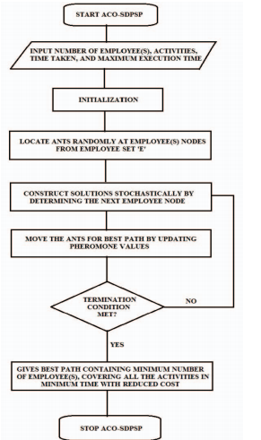
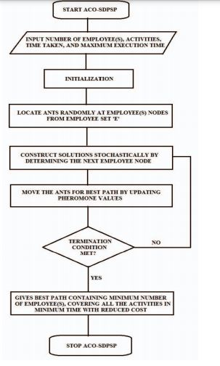

Figure 3. Flowchart of the ACO-SDPSP Approach

3. CONCLUSION AND FUTURE PROSPECT
Ant colony optimization is a promising approach for solving software development project scheduling problem. In this paper, an ACO-SDPSP approach using elitist behavior of ants has been proposed which can give results that can be obtained in the close proximity to the optimal results. The problem is clearly stated and explained with necessary diagrams and an example. The simplistic example shows the key steps of the proposed algorithm. This approach and developed algorithm can be utilized by software project managers as a standalone application for small software projects. Additionally, in future we plan to apply the methodology to more complex tasks and projects making it a web based application by considering more parameters. This can be done by hybridizing the proposed algorithm with other evolutionary algorithms. Experimental results are very encouraging and inferences that the methodology is promising in achieving the desired results.

Acknowledgements
I would like to thank my Guide Dr. Madhuri Gedam guidance throughout this work and giving it present shape. I am also grateful to Dr. Sunil Yadav for his kind support in this work.
References
[1] J.M. Odut, Solving the software project scheduling problem with
metaheuristics, Masterthesis, Universidad De Malaga, E.T.S. Ingenieria
Informatica; September 2012.
[2] B. Hughes, M. Cotterell, Software project management (Fourth edition,
Tata McGraw- Hill Edition, 2006).
[3] GR Heerkens, editor (McGraw- Hill, 2002).

04 lbert Jones and Luis C. Rabelo,” Survey of Job Shop Scheduling Techniques” Wiley Encyclopedia of Electrical and Electronics Engineering
https://en.wikipedia.org/wiki/Ant_colony_optimization_algorithms.

